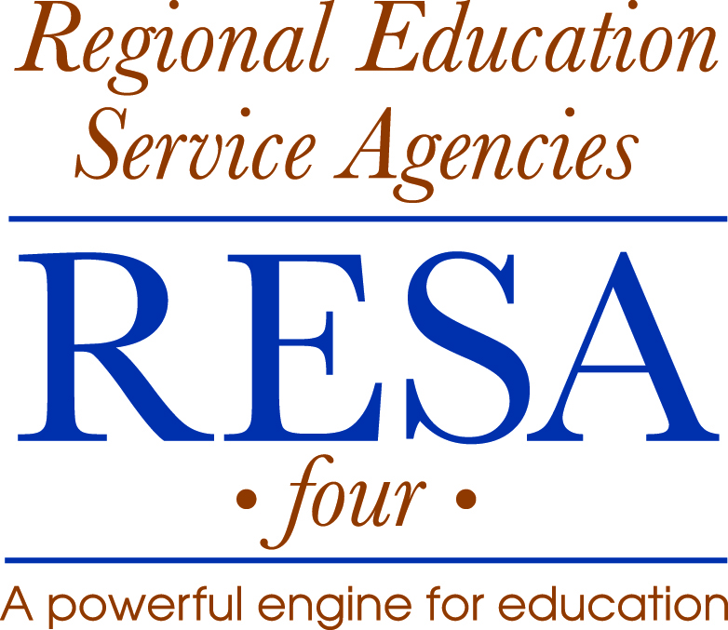

404 Old Main Drive • Summersville, WV 26651
304.872.6440 • Fax: 304.872.6442 • 800.251.7372 • http://resa4.k12.wv.us
Arthur L. Rogers, Jr., Executive Director

NOTICE OF JOB VACANCY

Posting Date: | January 14, 2013
Position: | Bus Operator Trainer
Employment Term: | Part-time (dependent upon funding)
Salary: | Based upon experience and qualifications. (Not to exceed $30.00/hour)
Qualifications: | - High school graduate or equivalent  - Class “B” CDL with P and S endorsements.  - Certified state bus operator instructor.  - Knowledge of state and federal laws and regulations related to bus operators.  - Skill in operating a bus and troubleshooting minor problems.  - Ability to teach required subjects to obtain state school bus operator’s certification.  - Ability to instruct CDL requirements.  - Ability to provide effective instruction in soft skills categories (i.e., confidentiality and intervention strategies).  - Ability to effectively communicate with staff, peers and community.  - Ability to establish and maintain effective working relationships.  - Evidence of effective oral and written communications.  - Proficiency in basic computer and presentation skills.
Resume Must Include: | - List of educational institutions attended, course of study, dates attended, and certificates earned.  - List of employers for the past ten years, including address and name of immediate supervisor(s).  - Description of responsibilities/work experiences in previous employment.  - Alignment of work experience with posted Job Description.  - List of at least three (3) references including addresses and telephone numbers.
Application Deadline: | Monday, January 21 2013, 4:00 p.m.
Send Application & Resume: | Arthur L. Rogers, Jr., Executive Director, RESA 4  404 Old Main Drive, Summersville, WV 26651
RESA 4 Will Grant Equal Employment Opportunities To All Persons, Regardless Of Race, Age, Religion, Color, Sex, Or National Origin And No Discrimination Based On These Factors Will Be Made In The Salary, Promotion, Demotion, Transfer, Or Termination Of Any Employee.

